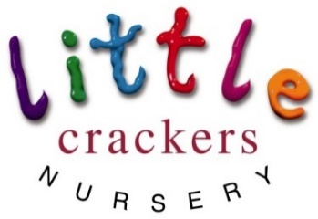
Weekly News

21st June 2019
Please take note of the important dates for nest week:
Important information  for those children moving into the Reception class at Crackley Hall School, here in September…  Tuesday 25th June: 6-7pm  Parents  Meet Mrs Glen-Roots, our Assistant Head responsible for Early Years and KS1, to receive your starter pack with information for next year.  Wednesday 26th June  Children  Induction Morning  Come in and spend the morning in your new Reception class! | PRE-SCHOOL GRADUATION!!!  Tuesday 25th June 2-3pm  unfortunately just 2 adults per child, thank you x  please can those children coming in the afternoon be with us by 1:45  School closes for the Summer  (term time children)  Wednesday 3rd July
At Little Crackers we are continually looking at ways to develop and improve our practice. This year we introduced a new way of displaying the children’s work and have allowed the children to access the resources they want, in order to direct their play and have greater control over their experiences. This has been messy and a little chaotic to look at, but has improved the quality of the interactions and learning.  We will continue this approach next year but with a greater emphasis on natural resources and ‘loose parts’.  Please could you help! If you are having a clear out and find any of the following bits and bobs we would really appreciate them… |  | Wood:  Curtain rings  Pegs and Buttons  Cotton reels  Sticks: big and small  Log slices all sizes | Metal:  Old bike wheels  Steering wheels  Pots and pans  Sieves and strainers  Cutlery  Baking trays
 |  | Found:  Conkers, Fir cones,  Seed pods, Gourds,  Stones and pebbles  Feathers | Other:  Cargo nets  Traffic cones  Milk/shopping crates  Wooden crates  Pallets
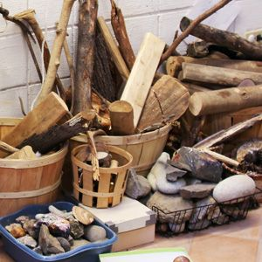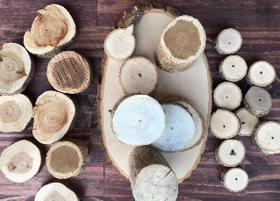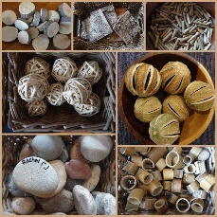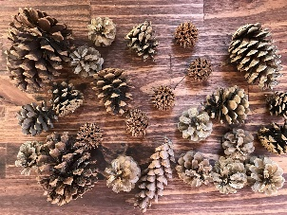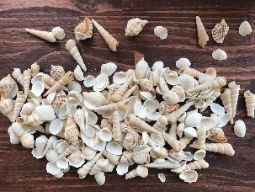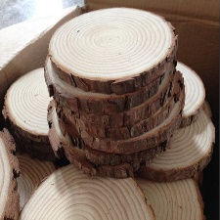
Little Crackers Nursery · Crackley Hall · St Joseph’s Park · Kenilworth · CV8 2FT
Telephone: 01926 514444 · Fax: 01926 514455 · e-mail: littlecrackers@crackleyhall.co.uk
www.crackleyhall.co.uk

Registered Charity Number 1087124 Company limited by guarantee Number 4177718

You can email Mrs Bird clarebird@crackleyhall.co.uk
or ring the nursery direct 01926 514456

